.

XML Framework Design Document CR JROE-6C2LB7
Status: | Issued
Version: | 1.3
Author: | Jakub Walkowicz
Contributor: | Aleks Pamir
Reviewers: | Stephen Mansfield
Team/Department : | System Libraries/Core Development

Contents
1 Introduction 3
1.1 Purpose and Scope 3
2 Overview 3
2.1 Problem Description 3
2.2 Design overview 4
2.2.1 Resource information fields format 4
2.2.2 Resolving criteria 5
2.2.3 Parser creation – sequence diagram 7
2.3 Documentation Deliverables 7
3 Detailed Design 9
3.1 Custom Resolver 9
3.1.1 IdentifyImplementationL 9
3.1.2 ListAllL 10
3.1.3 Plug-in Resource Information 10
3.1.4 Plug-in TImplementationProxy Entry point 10
3.1.5 Resolver DLL Capabilities 10
3.2 Xml::TParserImpl 10
3.2.1 Modified method – OpenL() 10
3.2.2 Modified method – ConstructParserL() 10
3.2.3 New public method – UpdateCurrentParser() 11
3.2.4 New public method – SetParser() 11
3.2.5 Attributes modification 11
3.3 Xml::CParser 11
3.3.1 Modified method – ConstructL() 12
3.3.2 New method – ConstructL() 12
3.3.3 New API method – NewL() 12
3.3.4 New API method – NewLC() 12
3.3.5 New API method – ParseBeginL() 12
3.3.6 Modified method – ParserBeginL() 12
3.4 Xml::CMatchData 12
3.4.1 Private method – InternalizeL() 14
3.4.2 Private method – ExternalizeL() 14
3.4.3 New API method – NewL(TDesC8&) 14
3.4.4 New API method – PackToBufferL() 14
3.4.5 New API method – ResolveL() 15
3.4.6 New API method – SetMimeTypeL() 15
3.4.7 New API method – SetVariantL() 15
3.4.8 New API method - SetRomOnly() 15
3.4.9 New API method - SetCaseSensitivity() 15
3.4.10 New API method – SetLeaveOnMany() 16
3.5 Current parsers 16
4 Further Information 16
4.1 References 16
4.2 Open issues 16
4.3 Document History 16

Introduction

Purpose and Scope
This document describes the changes required to the XML component in order to deliver
CR JROE-6C2LB7 – “Add more flexibility to parser selection in XML framework”. This CR is required for Symbian OS v9.2 (Bravo).
The target audience that this document is intended includes the Technology Architect and engineers within the System Libraries team.

Overview

Problem Description
Currently the XML Framework architecture allows a parser plugin to be defined for each mime type (example: “text/xml”) that is supported. When a client requires using a parser, it creates a parser object, specifying a mime type of the content to be parsed. The framework will then load an appropriate parser based on the mime type.
The issue is that it is not possible to support more than one parser for a particular mime type on the device. For instance there are various open source xml parsers available that a licensee may wish to use in addition to the Symbian provided parser. This would be useful for interoperability, porting other open source projects, performance etc. It is possible to completely replace the supplied xml parser currently, but it is not possible for the client to select a specific parser. Before the CR if two parsers were available that support the same mime type, it was undefined which one will be returned.
Below is the sequence diagram depicting the parser creation process in current code
(before CR implementation).
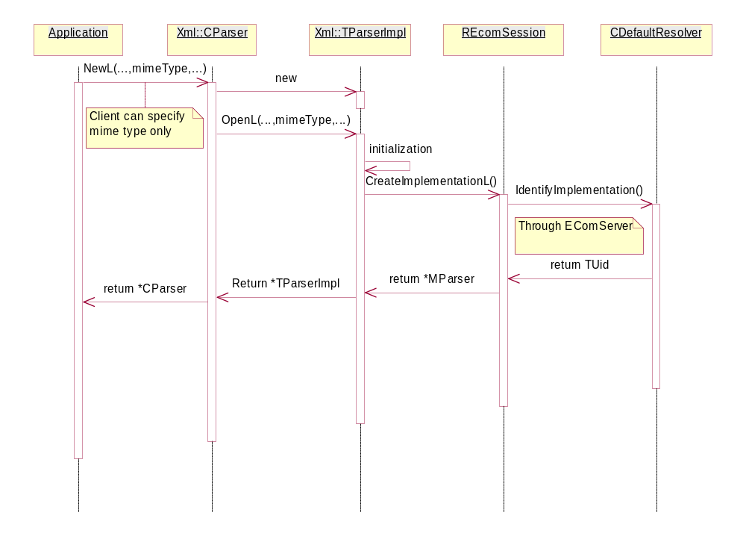

Design overview
This CR will deliver a generic extensible solution to the problem outlined in Problem Description. The following design should be easily extensible in the future allowing different matching criteria to be considered in a parser selection functionality of the framework.
This software change is self-contained within the XML component affecting no other components.
The XML framework is using ECOM architecture to discover plugin modules (parsers) for particular mime type available within the system. This CR implementation will extend current functionality by extending resolution criteria the calling application might specify. This can then be matched to the information in the opaque data field in a plug-in resource file providing resolution to the selection made. The default resolver provided by ECOM architecture doesn’t use opaque data to search for available plug-ins, therefore as a part of this CR a new custom resolver (CXmlCustomResolver) will be implemented to support the extended resolution functionality.
New API methods will be introduced to XML::CParser class to facilitate requested functionality:
static IMPORT_C CParser* Xml::CParser::NewL(const Xml::CMatchData& aCriteria, MContentHandler& aCallback)
static IMPORT_C CParser* Xml::CParser::NewLC(const Xml::CMatchData& aCriteria, MContentHandler& aCallback)
IMPORT_C void Xml::ParseBeginL(const CMatchData& aCriteria);
This CR doesn’t introduce BC break since it only extends the number of available API methods. Currently existing methods will remain unchanged.

Additionally new API class/object Xml::CMatchData will be created to supply extended matching criteria.

Diagram below depicts a general idea of XML framework resolving process. Green components are those, which need to be created or modified.
text/xmlsymbian
text/wbxmlsymbian

text/xmlfutureParser

text/wbxmlfutureParser

Plugin parser pool
Client Side
Server Side
Plugin pool
Client application
CParser –Client API – Extended only
TParserImpl
CEcomSession
CEComServerSession
CEcomServer
MParser
CXmlCustomResolver

Plugin custom resolver pool

Resource information fields format
Following plugin resource information fields will be used in customized XML resolver:
- Default_data
255 character string specifying parser’s supported mime types.
This field might include several entries separated by two vertical bar characters “||”.
Examples of valid fields:
- “text/xml” – parser supporting “text/xml” mime type
- “text/xml||text/wbxml” – parser supporting “text/xml” and “text/wbxml” mime types
- Opaque_data
255 character string.
This field might include several entries separated by two vertical bar characters “||”.
As per this design only the first field will be reserved, for a variant string, which will be matched against user provided data for more detailed resolution criteria.
As per this design there are no particular requirements what kind of string should be put as variant string. As an example it might be a plug-in name or vendor name.
Variant field max length is set to 32 characters.
Future extensions to the resolution process will make use of remaining non-allocated entries in opaque data field.
Examples of valid fields:
- “Symbianv1”
- “Symbian Extended”
- “Symbianv1||FutureResolvingExtension”

Resolving criteria
With new API introduction client application is given the choice how to use XML framework: it might just specify mime type of requested parser, or might use XML::CMatchData object to precisely identify required parser implementation. For more information on Xml::CMatchData implementation please refer to section 3.4.
All the data provided by client application in resolution criteria are mapped to the data specified in resource file. See section 2.2.1 for more details.
As high level rule forced by ECOM architecture XML framework will provide lowest Uid parser plugin implementation available in the system (see below for details).

Resolving down to one parser when criteria matches many
With the CR implementation the system might support several plug-ins for particular mime type. If the client application provides not enough information in matching criteria, the framework might end up with several possible parsers’ implementations to consider. Since ECOM architecture doesn’t provide any means to support for a best choice in such a circumstances, the implementation of this CR incorporates a logic to handle such an issue.
To narrow down the query to just one implementation, the general rule followed is to return the parser with the “lowest Uid”. Although Uid number allocation doesn’t correspond to a strict versioning order in every case, it is assumed to be a good approximation.
The exception to this general rule is in the case that no variant string is provided. In this case, to preserve backwards compatibility, a suitable Symbian-provided parser will be selected among the list ECOM provides. If there are multiple matching Symbian parsers, then the general rule will apply for this specific subset and the Symbian parser with the lowest Uid will be selected.
The “lowest Uid” rule is default behaviour of XML framework. If requested by the user the framework might just leave with an error to signal that the query can not be narrowed down to just one parser. That is to inform that the query doesn’t provide sufficient data or the system configuration is incorrect and there is an overlap in parsers configuration. The feature should be used mostly for testing and development purposes; however in some circumstances it might be beneficial to the user.

Mime type specification only
Following APIs would be used:
static IMPORT_C CParser* NewL(const TDesC8& aParserMimeType, MContentHandler& aCallback);
static IMPORT_C CParser* NewLC(const TDesC8& aParserMimeType, MContentHandler& aCallback);
The application calling those APIs will get the implementation with the lowest Uid (see section 2.2.2.1 for exceptions) in the list of available parsers for that particular mime type (aParserMimeType).
All parsers implementations are considered (ROM and non-ROM based). String matching is case sensitive.

Specific resolution criteria
Following APIs must be used:
static IMPORT_C CParser* NewL(const CMatchData& aCriteria, MContentHandler& aCallback);
static IMPORT_C CParser* NewLC(const CMatchData& aCriteria, MContentHandler& aCallback);
Client application will get the specific parser described in matching criteria – CMatchData (see section 3.4 for more information).
ROM based parsers only are considered when rom based flag in CMatchData is set. Case sensitivity is applied according to the state of case sensitivity flag in CMatchData.
The resolution process requires at least mime type information to be provided. Variant string is optional. Both strings are matched against its counterparts (see 2.2.1 section) in the resource information file. If the query doesn’t include variant string, only mime type string is used.
If the query is narrowed down to one parser, its implementation UID is returned. However if the framework ends up with many choices, the “lowest Uid” rule is applied or a resolution process leaves with an error code. The user may choose framework behaviour in such a case.

Examples
Examples assumptions:
- no case sensitivity, all parsers are ROM-based, all queries are for ROM-based parsers.
- ECOM framework provides only lowest Uid plugins
Plug-ins pool available in the system:
No./Uid | Version | Mime Type | Opaque
1 | 2 | text/xml | Symbian
2 | 1 | text/xml || text/wbxml | Symbian Adv
3 | 1 | text/xml | External
4 | 1 | text/wbxml | External
5 | 1 | text/xml || text/wbxml | External

Client application queries (CMatchData) and results:
Input Match parameters |  |  | Output | Explanation
Mime Type | Variant | Leave on many? | Result
text/xml | - | NO | 1 | Possible parsers: 1,2, 3, 5. Parser number 1 is Symbian-provided (has “Symbian” in Opaque field)
text/xml | - | YES | LEAVE | Possible parsers: 1,2, 3, 5. Request for leave if xml framework can not narrow down the query to one parser.  (KErrXmlMoreThanOneParser)
text/wbxml | - | NO | 2 | Possible parsers: 2, 4, 5. Parser number 2 has lowest Uid
text/xml | Symbian Adv | NO | 2 | Exact match for parser number 2
text/wbxml | External | NO | 4 | Possible parsers: 4, 5 . Parser 4 has lowest Uid.
text/wbxml_1 | External | YES | LEAVE | No parser available for “text/wbxml_1” mime type  (KErrXmlParserPluginNotFound)

Parser creation – sequence diagram
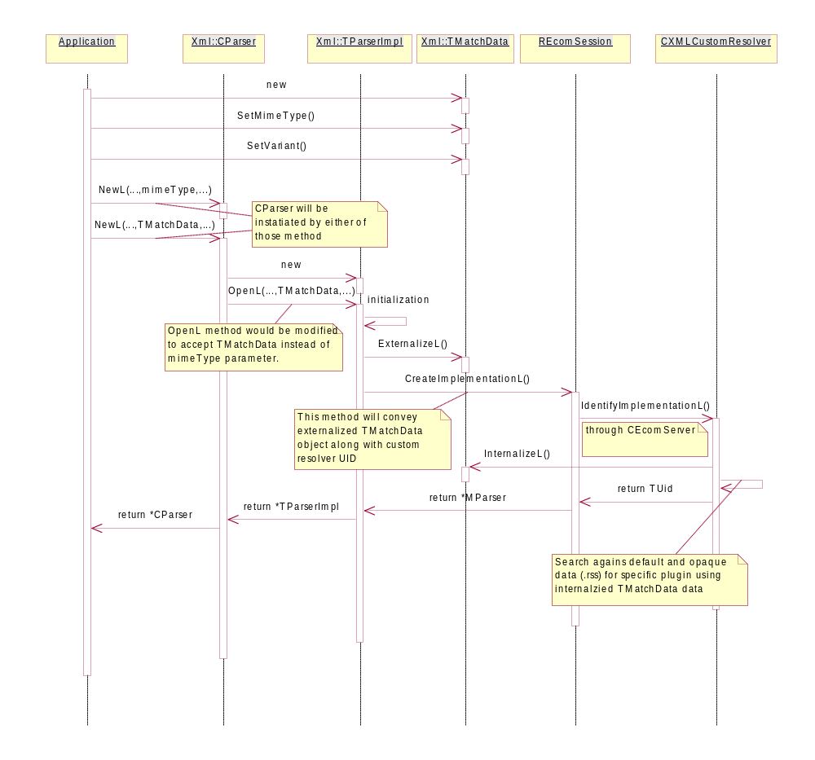

Documentation Deliverables
Document | Required? | Reason
Subsystem Architecture Description | X | No existing document.
Subsystem Functional Specification | ✓ | Updates to XML component sections required
Component Architecture Description | X | No existing document
Component Functional Specification | X | Covered by Subsystem Functional Specification.
How To Guide | ✓ | Create new document with section covering this CR enhancement.
API In-source Doxygen Comments | ✓ | Provide and update on ALL classes/methods/attributes touched.
Object Model | ✓ | Updates to //.../xml/documents/XmlFramework.mdl
Design Document | ✓ | This one and update //.../xml/documents/xml_framework_design.doc
Test Specification | ✓ | New document to be created for CR to describe new unit, component and integration test cases needed.
SDK Developer Library | ✓ | Review and provide ‘Guide’ material changes to technical author.

Detailed Design

Custom Resolver
ECOM Architecture is using external modules to perform plugin resolution. ECOM implementation comes with default resolver, which satisfies most of the common requirements. However for a purpose of extended resolution criteria its functionality is not enough. Therefore, as a part of this CR, new customized resolver will be developed to carry out extended matching process.
Each customized resolver is actually an implementation of ECOM interface, and it should thus be implemented in ECOM plug-in DLL and registered with ECOM by supplying a plug-in resource. The CXmlCustomResolver class implements the functionality of customized resolver. It inherits from CResolver and implements all required virtual abstract methods.
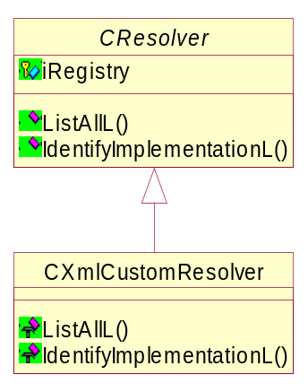

IdentifyImplementationL
Virtual TUid IdentifyImplementationL(TUid aInterfaceUid, const TEComResolverParams &aAdditionalParameters) const;
This method will make use of Xml::CMatchData::ResolveL() method to search for a particular implementation of parser plug-ins. It will return only one plugin UID.
Here are the basic steps the method is required to perform:
- Internalize the XML::CMatchData object provided as a descriptor by aAdditionalParameters parameter. The following method should be used:
Xml::CMatchData:: NewLC(const TDesC8& aPackage)
- Get a list of all implementations of particular aInterfaceUid by calling:
CResolver::ListAllL(aInterfaceUid)
- Pass received list to Xml::CMatchData::ResolveL() method to perform the resolution process.
For more information on resolution process see 2.2.2 section.
- If specified implementation is not found the value of KNullUid is returned. ECOM make a leave in such a case, so the user of XML framework will get KErrXmlParserPluginNotFound leave error.

Error conditions raised by this method:
- KErrAttribute
  - If aInterfaceUid is different than 0x101FAA0B, which is plugin parser’s interface UID

ListAllL
Virtual RImplInfoArray *ListAllL(TUid aInterfaceUid, const TEcomResolverParams &aAdditionalParameters) const;
This method won’t be supported by this customized resolver; therefore it would leave with an KErrNotSupported error code.

Plug-in Resource Information
Here is the information necessary to create the resource file for the XML custom resolver plugin:
- dll_uid
0x10273861
- interface_uid
0x10009D90 – always the same for customized resolver (CResolver)
- implementation_uid
0x10273862
- display_name
”XML Framework Custom Resolver”
- default_data
Dummy, not used
- opaque_data
Dummy, not used

Plug-in TImplementationProxy Entry point
The DLL containing the customer resolver will include the proxy-related standard code expected by ECOM so it may create the plugin implementation objects when the ECOM Server receives requests to use it.

Resolver DLL Capabilities
This resovler plug-in will be loaded by the ECOM Server to perform its resolution, therefore this requires the plug-in’s DLL to have, at least the ProtServ capability.

Xml::TParserImpl
Since the TParserImpl class hides the implementation of CParser class it will be necessary to modify this class to implement requested functionality.
TParserImpl is an internal class to the XML component therefore it is possible to change its public interface without any compatibility breaks. The process of plug-in provisioning is handled by OpenL() and ConstructParserL() functions therefore those should be changed along with private attributes list to accommodate the CR functionality.

Modified method – OpenL()
void TParserImpl::OpenL(const CMatchData& aMatchData, MContentHandler& aCallback)
New function declaration will allow more detailed specification of a parser the caller is searching for. Those data are all included in aMatchData parameter.
The method will remain unchanged with the exception for the aMatchData object reference, which will be passed to ConstructParserL() method, instead of mime type as it was previously.

Modified method – ConstructParserL()
MParser* TParserImpl::ConstructParserL(const CMatchData& aMatchData, MContentHandler& aCallback)
New function declaration will allow more detailed specification of a parser the caller is searching for. Those data are all included in aMatchData parameter.
Here are the basic steps the function should follow:
- Call PackToBufferL () method on aMatchData object to get the HBufC descriptor of externalized object
- Set up resolving parameters to find a plug-in with a matching parameters
(put externalized aMatchData as TEComResolverParams::iDataType)
- Pack parameters (TParserInitParams) to pass for parser object instantiation
- Call following method passing all the data along with UID of custom resolver:
static IMPORT_C TAny* REComSession::CreateImplementationL(TUid aInterfaceUid, TUid &aDtorIDKey, TAny *aConstructionParameters, const TEComResolverParams &aResolutionParameters, TUid aResolverUid);

New public method – UpdateCurrentParser()
void TParserImpl::UpdateCurrentMimeL (const CMatchData& aCriteria)
UpdateCurrentParser() will replace the UpdateCurrentMimeType() method.
It will just update iCurrentParserMatchParser attribute with received aCriteria object reference.

New public method – SetParser()
void TParserImpl::SetMimeTypeL(const CMatchData& aCriteria)
SetParser() will replace the SetMimeType() method.
The method will behave almost the same way with the exception to the call to UpdateCurrentMimeType() method, which should be updated with its new method definition

Attributes modification
Following private members will be modified as a part of this CR:
- HBufC::iDefMimeType attribute will be replaced by Xml::CMatchData::iDefParserMatchData
- HBufC::iCurrentMimeType attribute will be replaced by Xml::CMatchData::iCurrentParserMatchData.
Here is a list of method, which need to be modified in accordance to that change:
- ResetMimeTypeL()
Modified to ResetParserL()
- Close()
- OpenL()
- SetMimeTypeL()
Modified to SetParserL()
- UpdateCurrentMImeType()
Modified to UpdateCurrentParser()

Xml::CParser
Xml::CParser is an API class for XML component. All existing methods will remain unchanged and three new API methods will be added to this interface. Since this is only an interface extension no BC break is introduced. Some additional minor modification should be performed to existing CParser code to facilitate CR functionality. Most of those changes are related to interface change of Xml::TParserImpl.

Modified method – ConstructL()
void CParser::ConstructL(const TDesC8& aParserMimeType, MContentHandler& aCallback)
Additional functionality is required for this method to create Xml::CMatchData object with default data and mime type set up to aParserMimeType.
The new object will be passed to ConstructParser() method instead of mime type. This will convey the information to customized parser resolver that default parser is required.

New method – ConstructL()
void CParser::ConstructL(const CMatchData& aMatchData, MContentHandler& aCallback)
Introduction of this method will support new API methods.
Function implementation would be almost the same as the other ConstructL method, with the exception that aMatchData object reference will be passed to Xml::TParserImpl::OpenL method.

New API method – NewL()
static IMPORT_C CParser* Xml::CParser::NewL(const Xml::CMatchData& aCriteria, MContentHandler& aCallback)
This method will follow the generic 2-phase construction pattern. It will just pass its parameters to ConstructL method.
This method should be public interface of Symbian OS.

New API method – NewLC()
static IMPORT_C CParser* Xml::CParser::NewLC(const Xml::CMatchData& aCriteria, MContentHandler& aCallback)
This method will just follow the generic 2-phase construction pattern.
This method should be public interface of Symbian OS.

New API method – ParseBeginL()
IMPORT_C void ParseBeginL(const CMatchData& aCriteria);
Introduction of this method will support new API methods.
Function implementation would be almost the same as the other ParseBeginL() method, with the exception that aMatchData object reference will be passed to Xml::TParserImpl::SetParser() method.
This method should be public interface of Symbian OS.

Modified method – ParserBeginL()
EXPORT_C void ParseBeginL(const TDesC8& aDocumentMimeType)
The method will create new instance of Xml::CMatchData with default values and mime type given as parameter. This object should be then passed as reference to the TParserImpl::SetMimeTypeL() function call.

Xml::CMatchData
To support extended resolution functionality within XML framework the new API class/object will be introduced to allow more precise specification of required parser. The object will be created and set up as required on client side, then externalized and passed as a stream to customized resolver.
The new class Xml::CMatchData will contain three attributes:
- *HBufC8::iMimeType
A maximum of 255 character string.
Mime type the parser should support (example: “text/xml”).
Default value is an empty string.
- *HBufC8::iVariant
A maximum of 32 character string.
Parser type.
As per this design the format of this field is not forced. All plugin vendors should provide information for application programmers as to what kind of data should be given in this field to use their plug-in.
Default value is an empty string.
- iAddInfo
TUint32 value to support for 32 1-bit flags.
As per this design only three will have a meaning:
Bit | Default Value | Meaning when set
0x00000001 | FALSE | Resolve only ROM based implementations
0x00000002 | TRUE | Perform case sensitive resolution
0x00000004 | FALSE | Leave if the query is narrowed down to many parsers
0xFFFFFFFC |  | Reserved for future use, set to zero.
CMatchData object will be used to pass resolution information to customized XML resolver. This object should be streamed and passed as TEcomResolverParams::iDataType. Therefore, along with accessory methods to private attributes, additional routines are required to perform externalization and internalization. The class will provide also ResolveL()method to support for extended resolution criteria in customized resolver.

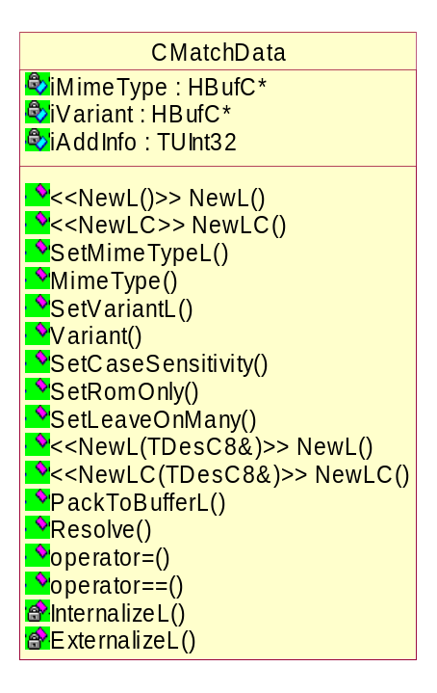 | Public Symbian OS APIs (@publishedAll):  - NewL(void)  - NewLC(void)  - SetMimeTypeL  - MimeType  - SetVariantL  - Variant  - SetCaseSensitivity  - SetRomOnly  - SetLeaveOnMany

Following sections provide the design for most of the CMatchData class’ methods. Obvious implementations are omitted.

Private method – InternalizeL()
void CMatchData::InternalizeL(RReadStream& aStream)
This private method will just extract data stored in RReadStrem object into CMatchData object. A format of the stream is precisely described in 3.4.2 chapter.
The method will be used by NewL(const TDesC&) method to internalize the object.

Private method – ExternalizeL()
void CMatchData::ExternalizeL(RWriteStream& aStream) const
This private method will pack private attributes into RWriteStream. A format of the stream is depicted in the table below.
Sequence | Length | Description
1 | sizeof(TInt16) | The length of following string stream
2 | Value of field 1 | Value of iMimeType
3 | sizeof(Tint16) | The length of following string stream
4 | Value of field 3 | Value of iVariant
5 | sizeof(TUInt32) | Value of iAddInfo

This method will be used by PackToBuffer( API method, to externalize the object to stream.

New API method – NewL(TDesC8&)
EXPORT_C CMatchData* CMatchData::NewL(TDesC8& aPackage)
This method creates a new CMatchData object using heap based stream buffer of externalized object. It should use InternalizeL method for that processing.
This method is intended to use by customized resolver to create a CMatchData object from a stream stored in a heap based buffer.
This interface should have no clients outside its own component. This is not a public interface of Symbian OS, thus declared as @internalComponent.

New API method – PackToBufferL()
EXPORT_C HBufC8* CMatchData::PackToBufferL() const
Since the externalized stream will be most likely used to put it as TEComResolverParams::iDataType descriptor, this method is added as a utility method to externalize the Xml::CMatchData object and return HBufC descriptor of the binary stream. Here are the basic steps the method should follow:
- Create a heap based descriptor of a proper size (see chapter 3.4.2 for details)
- Create RDesWriteStream object passing to the constructor the descriptor pointer
- Call ExternalizeL() method with the stream object as parameter
- Close the stream
- Return descriptor
Ownership of the returned object’s memory transfers to the caller of the method.
Error conditions raised by this method:
- KErrNoMemory – if memory allocation fails for heap based buffer.
This interface should have no clients outside its own component. This is not a public interface of Symbian OS, thus declared as @internalComponent.

New API method – ResolveL()
EXPORT_C TUid CMatchData::ResolveL(RImplInfoArray& aImplArray) const
This method performs the resolution process according to the rules given in 2.2.2 chapter. The input parameter is a list of available plugin parsers in the system. The method doesn’t modify aImplArray parameter.
This interface should have no clients outside its own component. This is not a public interface of Symbian OS, thus declared as @internalComponent.
Error condition raised by this method:
- KErrXmlMoreThanOneParser
  - If the query is narrowed down to more than just one parser and the user requested to leave in such a case.
This interface should have no clients outside its own component. This is not a public interface of Symbian OS, thus declared as @internalComponent.

New API method – SetMimeTypeL()
EXPORT_C void CMatchData::SetMimeTypeL(const TDesC8& aData)
The method sets up the attribute of iMimeType with the value given as parameter. New heap based buffer will be allocated and will replace the existing one
Error condition raised by this method:
- KErrArgument
  - If the length of argument is longer than KXmlMaxMimeTypeLength(255)
- KErrNoMemory
  - If there is no memory for new buffer allocation

New API method – SetVariantL()
EXPORT_C void CMatchData::SetVariantL(const TDesC8& aVariant)
The method sets up the attribute of iVariant with the value given as parameter. New heap based buffer will be allocated and will replace the existing one.
Error condition raised by this method:
- KErrArgument
  - If the length of argument is longer than KXmlMaxVariantLength(32)
- KErrNoMemory
  - If there is no memory for new buffer allocation

New API method - SetRomOnly()
EXPORT_C void CMatchData::SetRomOnly(TBool aSetting)
The bit 0x00000001 (KXmlRomOnlyFlag) is set according to the parameter. If set, it will notify customized resolver the request is for ROM-based parsers only.

New API method - SetCaseSensitivity()
EXPORT_C void CMatchData::SetCaseSensitivity(TBool aSetting)
The bit 0x00000002 (KXmlCaseSensitivityFlag) is set according to the parameter. The parser’s resolution process uses this setting to turn on or off case sensitivity while performing string comparisons.

New API method – SetLeaveOnMany()
EXPORT_C void CMatchData::LeaveOnMany(TBool aSetting)
The bit 0x00000003 (KXmlLeaveOnManyFlag) is set according to the parameter. If set, it will notify customized resolver to leave when xml framework narrows down the query to more than one parser. The parser with the lowest Uid in the list is returned in other case.

Current parsers
This CR modifies existing parsers resource information (opaque field) for all parsers provided currently with Symbian OS.
Mime Type | Implementation UID | Modified opaque field | Description
text/wbxml | 0x101FB6F3 | Symbian | WBXML Parser
text/xml | 0x101FAA0C | Symbian | XML Parser

Further Information

References
No. | Document Reference | Description
[1] | JROE-6C2LB7 | Add more flexibility to parser selection in XML framework
[2] | SMAD-6E3ETW | impact Analysis on CR by TA

Open issues

Document History
Date | Version | Status | Author | Description
6 April 2006 | 1.3 | Issued | Kai Duan | Defect fix changes applied - DEF080946
6 January 2006 | 1.2 | Issued | Andrew Burns | Issued approved document.
4 January 2006 | 1.1 | For Review | Aleks Pamir | Modified to reflect changes for multiple plugin selection behaviour after defect fix
7 September 2005 | 1.00 | Issued | Jakub Walkowicz | Issued approved document.
5 September 2005 | 0.22 | Draft | Jakub Walkowicz | Review Follow Up.
1 September 2005 | 0.21 | For Review | Jakub Walkowicz | Review Follow-Up. Additional changes due to IA change
22 August 2005 | 0.20 | For Review | Jakub Walkowicz
11 August 2005 | 0.16 | Draft | Jakub Walkowicz | Redesigned due to backward compatibility issues
3 August 2005 | 0.14 | Draft | Jakub Walkowicz | Resolution criteria updated
28 July 2005 | 0.13 | Draft | Jakub Walkowicz | Updated according to received comments
15 July 2005 | 0.12 | Draft | Jakub Walkowicz | Updated according to received recommendations
14 July 2005 | 0.1 | Draft | Jakub Walkowicz | First draft

